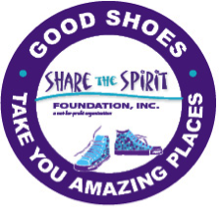 | VOLUNTEER FORM
Full Name
Address
City/State/Zip
Home Phone |  | Cell Phone
Email

Profession ______________________________________________________

What other organizations are you a volunteer?
How did you hear about Share the Spirit Foundation?

Share the Spirit provides new shoes and socks to disadvantaged children. We have several “Shoes for Kids” events throughout the year. We are a 501(c)3 organization. Please go to our website at www.sharethespirit.info to see more.

